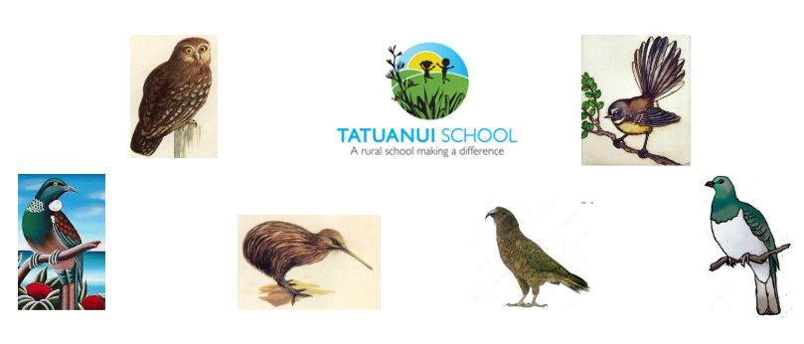

Our Vision

Empowered
21st Century Learners
Self-Motivated Growth Mindset, active learner not passive, inner desire to learn, light the fire,
excitement, intrinsic, time management, self-control, goal setting, reflective
Resilient emotional intelligence, don’t give up – give it a go, know when to compete and when
to co-operate, work hard to achieve, keep on keeping on, courageous, ok to make mistakes as long as you don’t repeat them, patience, mindset
Communicators valued contribution, actively involved, read, write and speak competently,
digitally literate, making connections
Collaborators working positively together, team player, open to new ideas and new ways of
thinking, co-operating, participate, accepting different points of view, prior knowledge, respect, active listener, patience
Problem Solvers Thinkers – critically and creatively, logically and divergently, “outside the box”,
persistent, perseveres, mindset , seek possibilities, risk taker, building on prior knowledge – ability to transfer

